LEAVE AND LICENSE AGREEMENT
This agreement is made and executed on Date 28/03/2025 at Pune.

Between

Name: MR. NEERAJ THAKUR
Age : about 43 years, occupation : Employed Aadhar No: 7074 6530 9220
Email id:- neeraj.thakur@rediffmail.com Mob No:- +1 (248) 766-1579 Residing at: Flat No:- A13-804, Sparklet, Megapolis, Near Tcs, Hinjawadi Phase-3, Maan, Pune, Maharashtra-411057.

Hereinafter called ‘the licensor (which expression shall mean and include the licensor above Named and also his/her/their respective heirs, successors, assigns, executors and administrators).

And

Name: MR. ANKIT AKASH
Age : about 33 years, occupation : service Aadhar No : 3653 4915 9521
Residing at : Road No 5,Hill View Road, Near Birsa Blood Bank, Bariatu, Ranchi, Jharkhand-834009.

Name: MRS. SHIVANGI THAKUR
Age : about 32 years, occupation : Unemployed Aadhar No : 8361 8876 9763
Residing at :Road No 5,Hill View Road, Near Birsa Blood Bank, Bariatu, Ranchi, Jharkhand-834009.

Name: MR. GAURAV THAKUR
Age: about 27 years, occupation : service Aadhar No: 7752 0949 3609
Residing at: TEACHERS COLONY, KHERAJPUR ROAD, LAHERIASARAI, DARBHANGA, BIHAR-846001.

Hereinafter called ‘the licensee’ (which expression shall mean and include only licensee Above named).

Whereas the licensor is absolutely seized and possessed of and or otherwise well and Sufficiently entitled to all that constructed portion being unit described in schedule i hereunder Written and are hereafter for the sake of brevity called or referred to as licensed premises and Is/are desirous of giving the said premises on leave and license basis under section 24 of the Maharashtra rent control act, 1999.

And whereas the licensee herein is in need of temporary premises for residential use Has/have approached the licensor with a request to allow the licensee herein to use and occupy The said premises on leave and license basis for a Period Of 11 Months Commencing From 01/04/2025 And Ending On 28/02/2026 On terms and subject to conditions hereafter appearing.

And whereas the licensor have agreed to allow the licensee herein to use and occupy the Said licensed premises for his aforesaid residential purposes only, on leave and license basis For above mentioned period, on terms and subject to conditions hereafter appearing;

Now therefore it is hereby agreed to, declared and recorded by and between the parties hereto as follows:-

- Period: That the licensor hereby grants to the licensee herein a revocable leave and license, To occupy the licensed premises, described in schedule I hereunder written without creating any Tenancy rights or any other rights, title and interest in favour of the licensee for a period of 11 Months commencing from Mentioned As above and ending on Mentioned As above.

- License Fee & Deposit: That the licensee shall pay to the licensor license fee at the rate of Rs.33,000/- per month towards the compensation and Rs.40,000/- interest free refundable deposit, for the use of the said licensed Premises. The amount of monthly compensation license fee shall be payable within first five days Of the concerned month of leave and license.

- Payment Of Deposit: That the licensee have paid / shall pay the above mentioned Deposit/premium as mentioned above by Online. Amount Mentioned As above.

- Maintenance Charges: That the all outgoings including all rates, taxes, levies, assessment, Maintenance charges, non-occupancy charges, etc. In respect of the said premises shall be paid By the licensor.

- Electricity Charges: The licensee herein shall pay the electricity bills directly for energy Consumed on the licensed premises and should submit original receipts to licensor indicating the electricity bills are paid.

- Use: That the licensed premises shall only be used by the licensee for residential Purpose. The licensee shall maintain the said premises in its existing condition and damage, if any, Caused to the said premises, the same shall be repaired by the licensee at its own cost subject to Normal wear and tear. The licensee shall not do anything in the said premises which is or is likely To cause a nuisance to the other occupants of the said building or to the prejudice in any manner to The rights of licensor in respect of said premises or shall not do any unlawful activities prohibited By state or central government.

- Alteration: That the licensee shall not make or permit to do any alteration or addition to the Construction or arrangements (internal or external) to the licensed premises without previous Consent in writing from the licensor.

- No Tenancy: That the licensee shall not claim any tenancy right and shall not have any right to Transfer, assign, and sublet or grant any license or sub-license in respect of the licensed premises Or any part thereof and also shall not mortgage or raise any loan against the said premises.

- Inspection: That the licensor shall on reasonable notice given by the licensor to the licensee Shall have a right of access either by himself / herself / themselves or through authorized Representative to enter, view and inspect the licensed premises at reasonable intervals.

- Cancellation: That, subject to the condition of lock in period (if any), if the licensee commits Default in regular and punctual payments of monthly compensation as herein before mentioned or Commit/s breach of any of the terms, covenants and conditions of this agreement or if any Legislation prohibiting the leave and license is imposed, the licensor shall be entitled to revoke And / or cancel the license hereby granted, by giving notice in writing of one month and the Licensee too will have the right to vacate the

said premises by giving a notice in writing of one Month to the licensor as mentioned earlier.

- Possession: That the immediately at on the expiration or termination or cancellation of this Agreement the licensee shall vacate the said premises without delay with all his goods and Belongings. In the event of the licensee failing and / or neglecting to remove himself and / or his Articles from the said premises on expiry or sooner determination of this agreement, the licensor Shall be entitled to recover damages at the rate of double the daily amount of compensation per Day and or alternatively the licensor shall be entitled to remove the licensee and his belongings From the licensed premises, without recourse to the court of law.

- Furniture and Appliances: The said premise is having the furniture and appliances Mentioned in the schedule ii. The licensee shall maintain the said furniture and appliances in the Said premises in its existing condition and damage, if any, caused to the said furniture and Appliances, the same shall be repaired by the licensee/s at its own cost subject to normal wear And tear.

- After completion of 11 months there will be increase in rent 10 Percent as per market and mutual understanding between LICENSOR and LICENSEE.

SCHEDULE I

(Being the correct description of premise apartment/flat which is the subject matter of these Presents).

All that constructed portion being residential unit bearing APARTMENT/ FLAT NO- A13-804, built- up: 760 Square feet, situated on the 8th floor of a building known as "SPARKLET, MEGAPOLIS" standing on the plot of land bearing PLOT NO. R1/1 TO R1/4, PHASE-3, RAJIV GANDHI INFOTECH PARK, ROAD: HINJAWADI, LOCATION: MAAN, OF VILLAGE: MAAN, PUNE, TALUKA-MULSHI, MAHARASHTRA- 411057.

SCHEDULE II
Sr. No. | Furniture | Quantity
 | Hall
1 | Sofa Cum Bed (L shaped) | 1
2 | TV unit/showcase | 1
3 | Shoe Rack | 1
4 | Center table with 4 stools | 1
5 | 2 Indian seating with 5 cushions | 1
6 | Corner Table | 1
7 | Curtains and curtain rod | 2
8 | TV | 1
9 | Kid’s chair | 1
10 | Tata sky connection | 1
 | Balcony
11 | Dryer Pulley | 1
12 | Covered with artificial grass | 1
13 | Big ladder | 1
14 | Kid’s Scooter | 1
 | Kitchen
15 | Fridge | 1
16 | 2 Door Almira big | 1
17 | 2 door Almira medium height | 1
18 | Modular kitchen (L shaped) with  shelves | 1
19 | Gas stove (3 burners) | 1
20 | Microwave | 1
21 | Water purifier | 1
22 | Exhaust | 1
23 | Gas Cylinders | 2
24 | 1 mixer grinder with 3 pots | 1
 | Bedroom
25 | 1 queen sized bed with mattress  (hydraulic) | 1

26 | 4 door wardrobe | 1
27 | Dressing Table | 1
28 | Side Table | 1
29 | Curtains with curtain rod | 1
30 | Cloth hanger | 1
 | Master Bedroom
31 | 1 queen sized bed with mattress  (hydraulic) | 1
32 | 5 door wardrobe | 1
33 | Dressing Table | 1
34 | Side Tables | 3
35 | Cooler | 1
36 | Cloth Hanger | 1
37 | Curtains with curtain rod | 1
38 | Folding Study Table | 1
39 | Laundry Bag | 1
 | Bathroom
40 | Geysers | 2
41 | Cloth Hangers | 2
42 | Mirrors | 2
43 | Corner Glasses | 5
44 | Fully Automatic Washing Machine | 1
45 | Cloth Dryer rope
46 | Exhaust | 2
 | Basic Fittings
47 | Tube Light | 4
48 | Fans | 5
49 | CFL | 4

In witness whereof the parties hereto have set and subscribed their respective signatures hereto in the presence of witness, who are Identifying the executants, on the day, month and year first above written.

Witness
1.

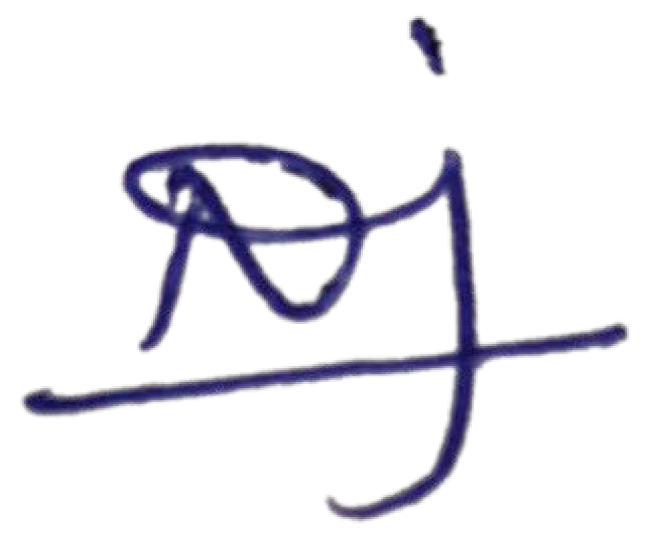
2.

MR. NEERAJ THAKUR
The Licensor

MR. ANKIT AKASH
The Licensee

MRS. SHIVANGI THAKUR
The Licensee

MR. GAURAV THAKUR
The Licensee

